Name: Edith Njoki Wangui

Email Address: edith.wangui@womentechsters.org

Wireshark practical Activity

1. Browser running Http

Version 1.1

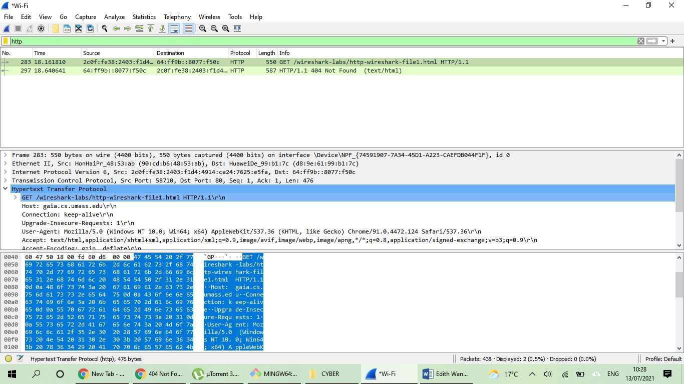

1. Languages indicated on the browser

English –US

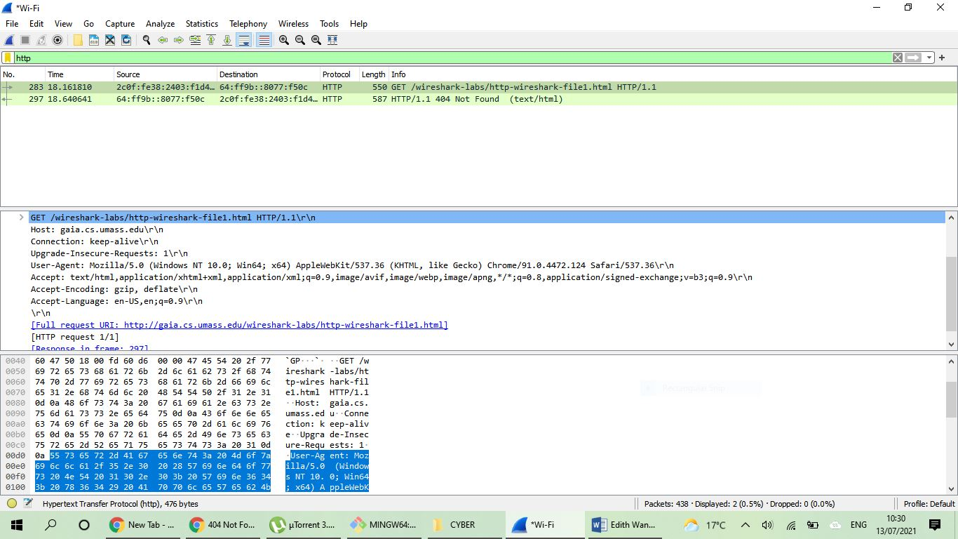

English -US

1. What is the IP Address of the computer and the server

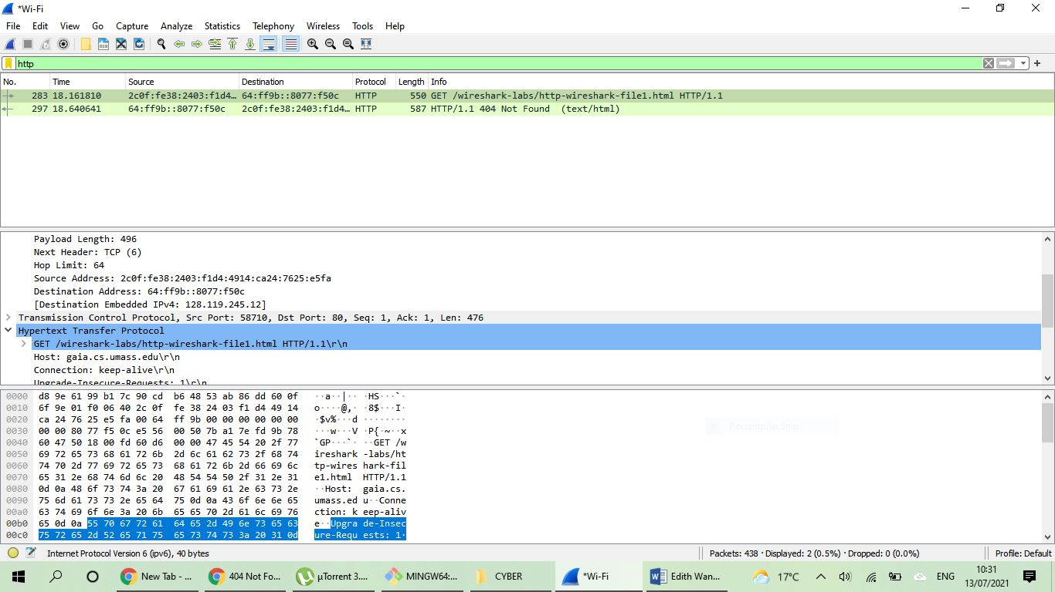

IP address of the server

IP address of the computer

1. Status code returned

Code 404

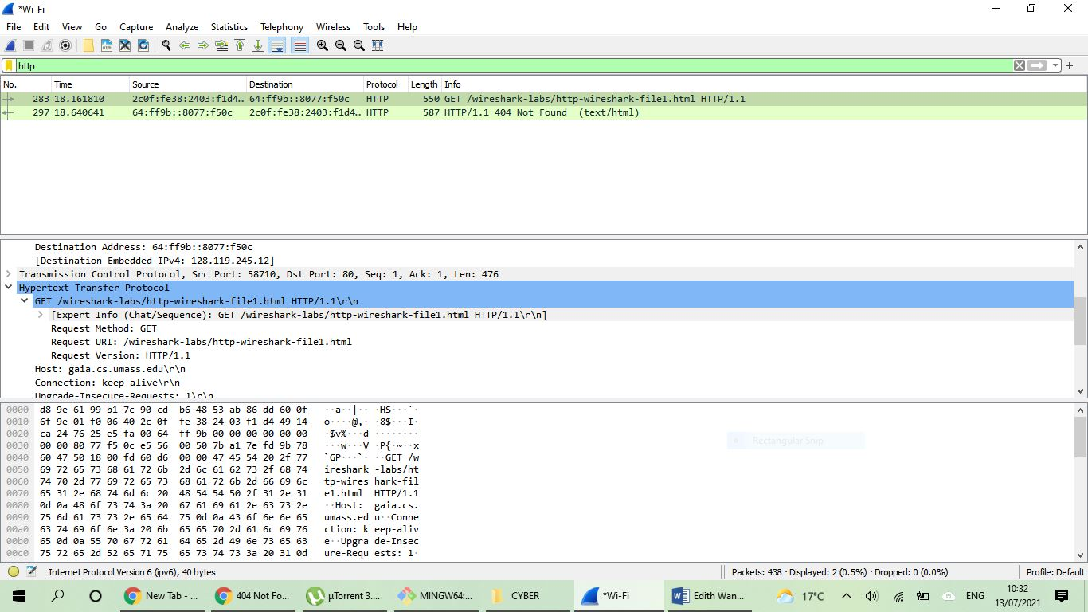

Code 404

1. When was the html file last modified

Command http.last_modified shows no date

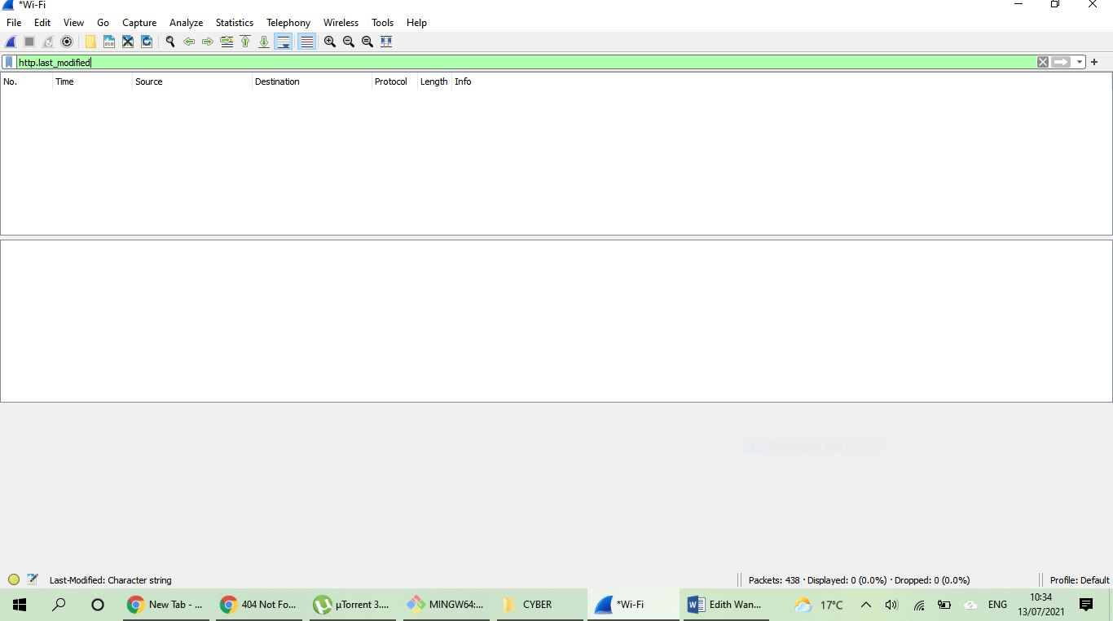

Does not return modified date

Shows only the date of analysing packets

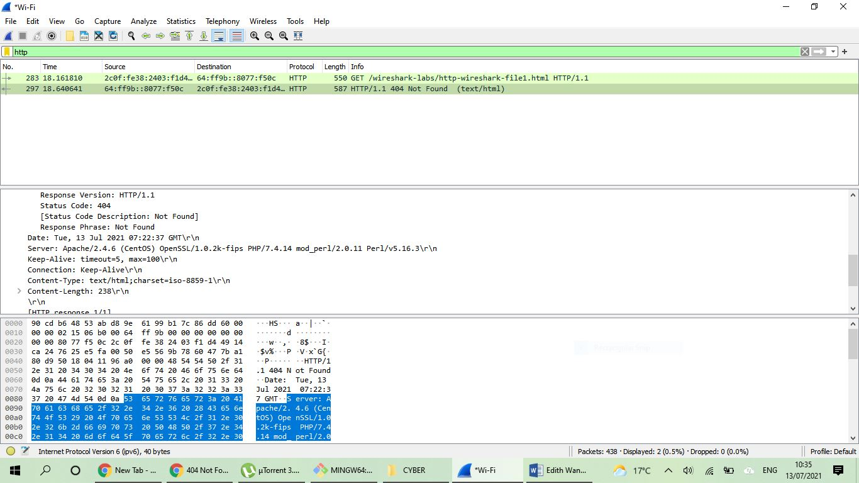

Shows only the date of analysing packets

1. Bytes of content

Bytes 238

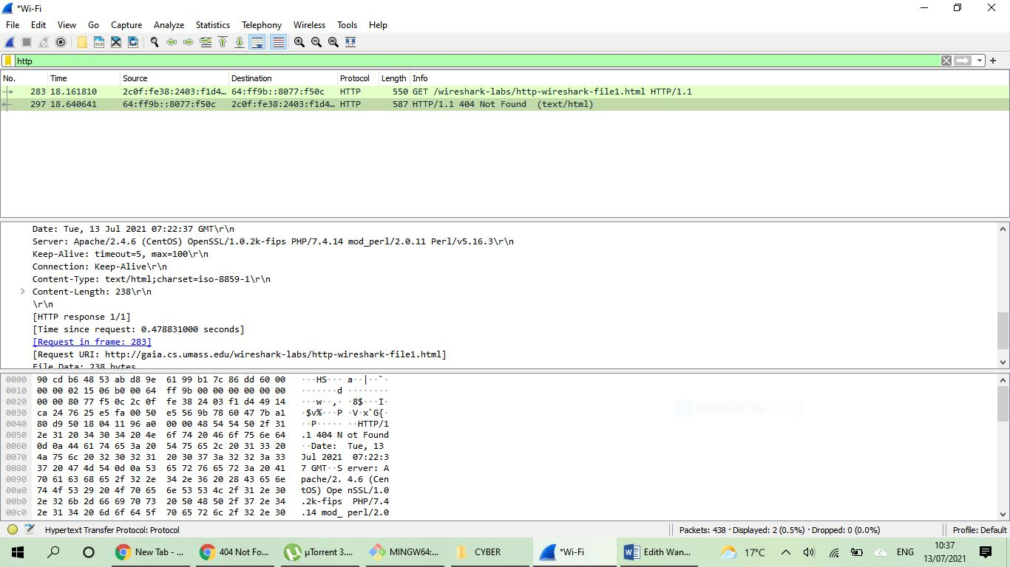

Content length 238

1. Http headers

All http headers are displayed

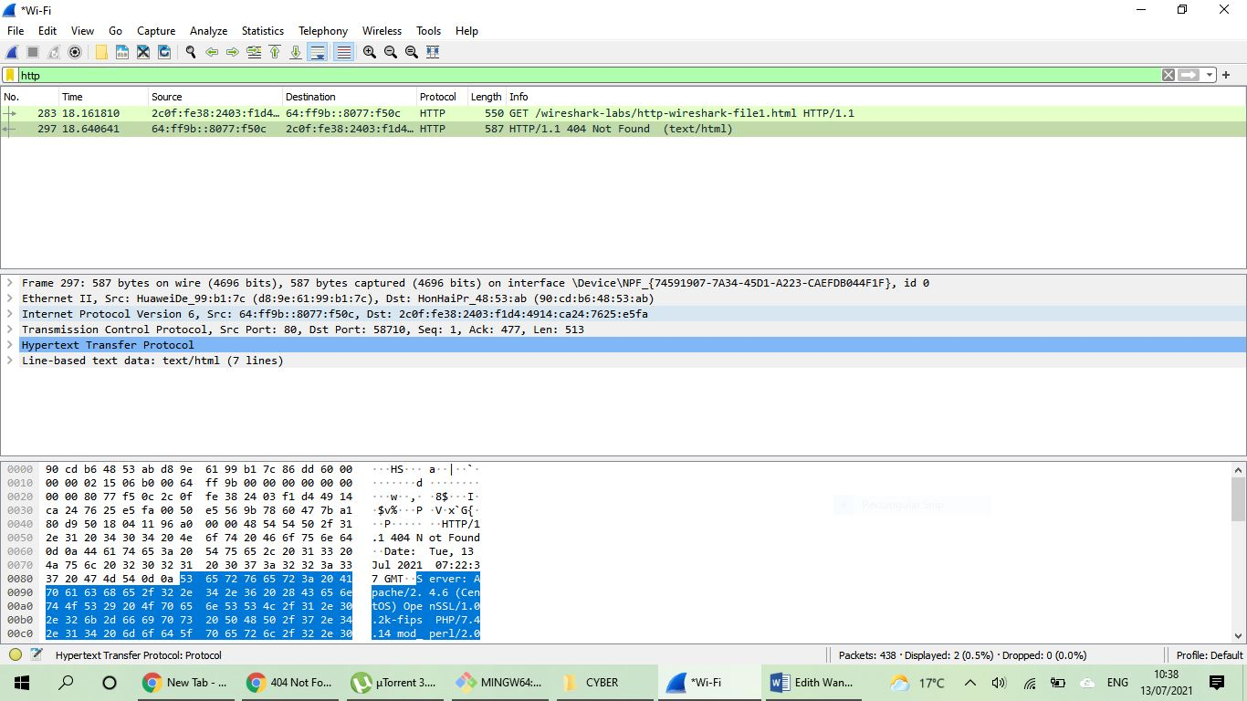

All headers are there

**Conclusion**

The packet sniffer shows http version of both the computer and the server. The language the browser will accept on the server, IP addresses of the source and the destination, when the file was last modified, and the analysing date. It also shows the content length returned to the browser after searching. Most of the information can be found on the packet content pane.